

Semester Two Examination, 2017

Question/Answer booklet

MATHEMATICS

SOLUTIONS
METHODS
UNITS 1 AND 2

Section One:

Calculator-free

Student Number: In figures

In words

Your name

Time allowed for this section
Reading time before commencing work: five minutes
Working time: fifty minutes

Materials required/recommended for this section
To be provided by the supervisor
This Question/Answer booklet
Formula sheet

To be provided by the candidate
Standard items: pens (blue/black preferred), pencils (including coloured), sharpener, correction fluid/tape, eraser, ruler, highlighters

Special items: nil

Important note to candidates
No other items may be taken into the examination room. It is your responsibility to ensure that you do not have any unauthorised material. If you have any unauthorised material with you, hand it to the supervisor before reading any further.

Structure of this paper

Section | Number of questions available | Number of questions to be answered | Working  time (minutes) | Marks available | Percentage of examination
Section One:  Calculator-free | 8 | 8 | 50 | 52 | 35
Section Two:  Calculator-assumed | 13 | 13 | 100 | 98 | 65
 |  |  |  | Total | 100

Instructions to candidates

1. The rules for the conduct of examinations are detailed in the school handbook. Sitting this examination implies that you agree to abide by these rules.

2. Write your answers in this Question/Answer booklet.

3. You must be careful to confine your response to the specific question asked and to follow any instructions that are specified to a particular question.

4. Additional working space pages at the end of this Question/Answer booklet are for planning or continuing an answer. If you use these pages, indicate at the original answer, the page number it is planned/continued on and write the question number being planned/continued on the additional working space page.

5. Show all your working clearly. Your working should be in sufficient detail to allow your answers to be checked readily and for marks to be awarded for reasoning. Incorrect answers given without supporting reasoning cannot be allocated any marks. For any question or part question worth more than two marks, valid working or justification is required to receive full marks. If you repeat any question, ensure that you cancel the answer you do not wish to have marked.

6. It is recommended that you do not use pencil, except in diagrams.

7. The Formula sheet is not to be handed in with your Question/Answer booklet.

Section One: Calculator-free 35% (52 Marks)
This section has eight (8) questions. Answer all questions. Write your answers in the spaces provided.

Working time: 50 minutes.

Question 1 (7 marks)
(a) The tenth term of an arithmetic sequence is 67 and the fourteenth term is 51.

Determine the sum of the first 20 terms of the sequence. (4 marks)

Solution
$$d=\frac{51-67}{14-10}=-\frac{16}{4}=-4$$

$$67=a+\left(10-1\right)\left(-4\right)$$
$$a=103$$

$$S_{20}=\frac{20}{2}\left(2\left(103\right)+\left(20-1\right)\left(-4\right)\right)$$

$$S_{20}=10\left(206-76\right) \\ =1300$$

Specific behaviours
determines common difference
determines first term
substitutes correctly into sum formula
evaluates sum

(b) The limiting sum of the series $x+x^{2}+x^{3}+x^{4}+…$ is $24$.

Determine the value of $x$. (3 marks)
Solution
$$\text{GP}: a=x, r=x$$

$$24=\frac{x}{1-x}$$
$$24-24x=x$$

$$x=\frac{24}{25}$$

Specific behaviours
indicates sequence is geometric
substitutes into sum to infinity formula
determines value of $x$

Question 2 (5 marks)
(a) Determine $f'(x)$ if

(i) $f\left(x\right)={4x}^{6}-x-1$. (1 mark)
Solution
$$f^{'}\left(x\right)=24x^{5}-1$$

Specific behaviours
differentiates

(ii) $f\left(x\right)={\left(5x+2\right)}^{2}$. (2 marks)
Solution
$$f\left(x\right)=25x^{2}+20x+4$$

$$f^{'}\left(x\right)=50x+20$$

Specific behaviours
expands
differentiates

(b) The area of an oil slick, at time $t$ hours, is given by $A\left(t\right)=90+1.5t^{2}-0.2t^{3}$ square meters. Determine the instantaneous rate of change of the area of the slick when $t=10$ hours. (2 marks)
Solution
$$A^{'}\left(t\right)=3t-0.6t^{2}$$

$$A^{'}\left(10\right)=30-60=-30 {\text{m}}^{2}\text{/h}$$

Specific behaviours
differentiates correctly
substitutes and simplifies

Question 3 (7 marks)
(a) Evaluate $x^{2a}∙x^{b}$ when $x=64$, $a=2$ and $b=-4.5$. (3 marks)

Solution
$$x^{2a+b}={64}^{-\frac{1}{2}}$$
$$=\frac{1}{\sqrt{64}}$$
$$=\frac{1}{8}$$

Specific behaviours
eliminates negative indices
eliminates fractional indices
states value

(b) The first two terms of a geometric sequence are $3×{10}^{-4}$ and $6×{10}^{-6}$. Calculate the fifth term of the sequence, giving your answer in scientific notation. (4 marks)

Solution
$$r=\frac{6×{10}^{-6}}{3×{10}^{-4}}=2×{10}^{-2}$$

$$T_{4}=\left(3{×10}^{-4}\right){\left(2×{10}^{-2}\right)}^{4}$$

$$=3×{10}^{-4}×2^{4}×{10}^{-8}$$
$$=48×{10}^{-12}$$

$$=4.8×{10}^{-11}$$

Specific behaviours
evaluates ratio
indicates expression for 4th term
simplifies
expresses term in scientific notation

Question 4 (8 marks)
The graph of $y=ax^{3}+bx+c$ has a stationary point at $(2, 29)$ and a gradient of $18$ when $x=1$.

(a) Determine the values of the constants $a$, $b$ and $c$. (6 marks)
Solution
$$\frac{dy}{dx}=3ax^{2}+b \\ 0=3a{\left(2\right)}^{2}+b⇒12a+b=0 \\ 18=3a{\left(1\right)}^{2}+b⇒3a+b=18 \\ 9a=-18⇒a=-2 \\ b=-12\left(-2\right)=24 \\ 29=-2{\left(2\right)}^{3}+24\left(2\right)+c⇒c=-3$$

$$a=-2, b=24, c=-3$$

Specific behaviours
differentiates equation
equation using $y^{'}=0$ when $x=2$
equation using $y^{'}=18$ when $x=1$
determines value of $a$
determines value of $b$
uses $(2, 29)$ to determine $c$

(b) Determine the coordinates of any other stationary points. (2 marks)
Solution
$$\frac{dy}{dx}=-6x^{2}+24 \\ =0 \text{when} x=±2$$

$$-2{\left(-2\right)}^{3}+24\left(-2\right)-3=-35$$

$$\text{Other SP at} (-2, -35)$$

Specific behaviours
determines other $x$-coordinate
states coordinates

Question 5 (7 marks)
Solve the following equations for $x$:

(a) $2\sin{x}+1=0, 0≤x≤360°$. (2 marks)
Solution
$$\sin{x}=-\frac{1}{2}⇒x=210°, 330°$$

Specific behaviours
determines one solution
determines both solutions

(b) $\begin{matrix}x+4 \\ \overline{x-3}\end{matrix}=\begin{matrix}3 \\ \overline{4}\end{matrix}$ . (2 marks)

Solution
$$4\left(x+4\right)=3\left(x-3\right)$$
$$4x+16=3x-9$$
$$x=-25$$

Specific behaviours
cross multiplies and expands
correct solution

(c) ${\left(3x-2\right)}^{2}-25=0$. (3 marks)
Solution
$${\left(3x-2\right)}^{2}=25$$
$$3x-2=±5$$

$$3x=7, -3$$

$$x=\frac{7}{3}, x=-1$$

Specific behaviours
square roots both sides, with $±$ one side
solves for $3x$
correct solutions

Question 6 (6 marks)
The graph of the function $y=f(x)$ is shown below, where

$$f\left(x\right)=\frac{5}{x-1}.$$
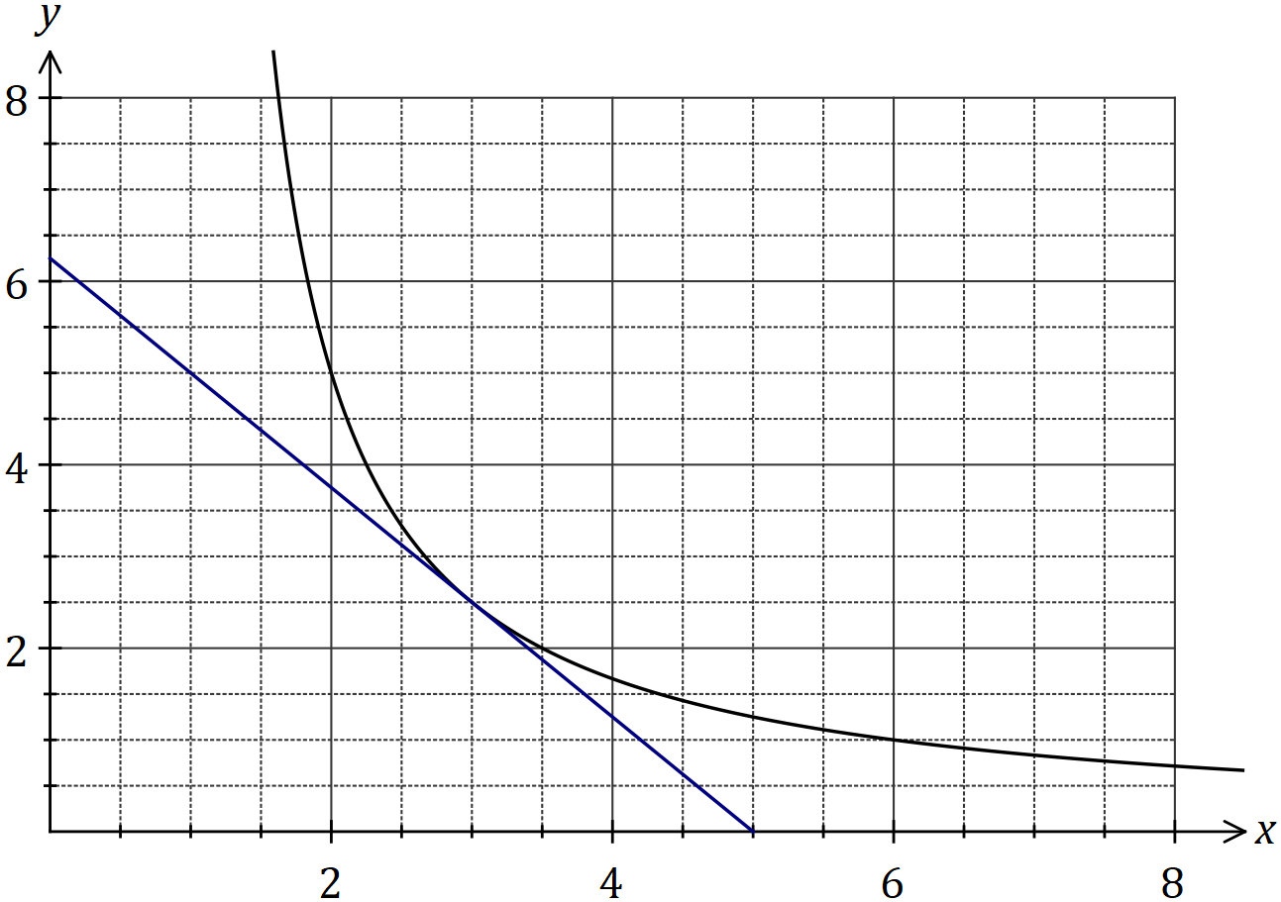

(a) Draw the tangent to the graph at $x=3$ so that it cuts both axes, and use the tangent to estimate the value of $f'(3)$. (3 marks)
Solution
See graph. Slope of tangent $≈-\frac{6}{5}≈-1.2$

Specific behaviours
tangent drawn as straight line
tangent cuts $y$-axis between 5.5 and 7
estimate of gradient of tangent

(b) Calculate the average rate of change of the function as $x$ increases from $3$ to $3.5$.
(3 marks)
Solution
$$f\left(3\right)=2.5, f\left(3.5\right)=2$$

$$\text{ARoC}=\frac{2-2.5}{3.5-3}=\frac{-0.5}{0.5}=-1$$

Specific behaviours
calculates change in $x$-coordinates
calculates change in $y$-coordinates
states correct gradient

Question 7 (7 marks)
(a) Determine the coefficient of the $n^{3}$ term in the expansion of ${\left(3n-1\right)}^{5}$. (3 marks)

Solution
$${\left(3n-1\right)}^{5}=…+\left(\begin{matrix}5 \\ 2\end{matrix}\right){\left(3n\right)}^{3}{\left(-1\right)}^{2}+…$$

$$\text{Coefficient is} 10×27×1=270$$

Specific behaviours
identifies correct term
uses $\left(\begin{matrix}5 \\ 2\end{matrix}\right)$ in expansion
correct coefficient

(b) Consider the equation $x^{3}-7x^{2}+36=0$.

(i) Show that $x=3$ is a solution of the equation. (1 mark)
Solution
$$27-63+36=63-63=0$$

Specific behaviours
substitutes and expands

(ii) Determine all other solutions. (3 marks)

Solution
$$x^{3}-7x^{2}+36=\left(x-3\right)\left(x^{2}-4x-12\right) \\ =\left(x-3\right)\left(x+2\right)\left(x-6\right)$$

$$\text{Other solutions}:x=-2, x=6$$

Specific behaviours
determines quadratic factor
factorises cubic
states other two solutions

Question 8 (5 marks)
The graph of $y=f(x)$ is shown below, where $f\left(x\right)=\sqrt{2x+1}$.

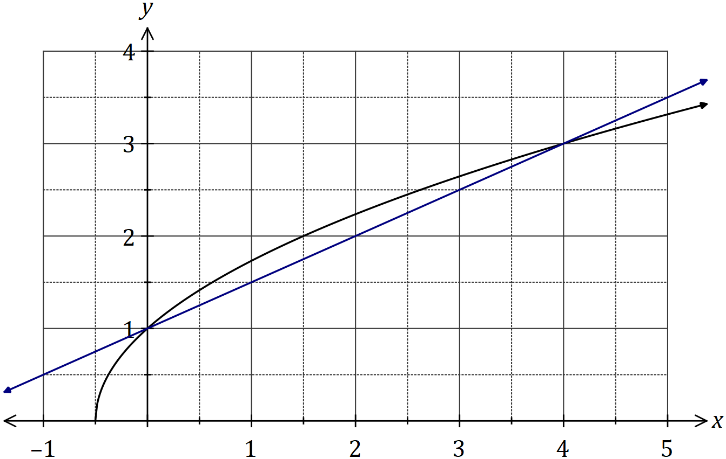

The difference quotient is shown here:
$$\frac{f\left(x+h\right)-f(x)}{h}$$

(a) Add to the graph a secant whose slope represents the difference quotient when $x=0$ and $h=4$, and state the value of this slope. (2 marks)
Solution
See graph - slope is $\frac{1}{2}$
Specific behaviours
secant through (0, 1) and (4, 3)
correct slope

(b) Evaluate the difference quotient as $h→0$ to determine the slope of $f(x)$ when $x=0$.
(3 marks)
Solution
$$\frac{f\left(x+h\right)-f\left(x\right)}{h}=\frac{\sqrt{0+2h+1}-\sqrt{0+1}}{h} \\ =\frac{\sqrt{2h+1}-1}{h}×\frac{\sqrt{2h+1}+1}{\sqrt{2h+1}+1} \\ =\frac{2h}{h\left(\sqrt{2h+1}+1\right)} \\ ={\left.\frac{2}{\sqrt{2h+1}+1}\right|}_{h=0} \\ =1$$

Specific behaviours
substitutes $f(x)$, $x=0$ and simplifies
removes surd from numerator
substitutes $h=0$ and simplifies

Additional working space

Question number: _________

© 2017 WA Exam Papers. Kennedy Baptist College has a non-exclusive licence to copy and communicate this document for non-commercial, educational use within the school. No other copying, communication or use is permitted without the express written permission of WA Exam Papers. SN245-102-2.

